ICIS 2026 Lisbon Title
Arts- and Culture-based Artefacts
<<<Authors SHOULD NOT BE in the file>>>

Proof-of-Concept Submission
First Round: We ask that authors follow these basic guidelines when submitting to ICIS for the call for arts- and culture-based artefacts. In essence, you should format your proof-of-concept submission exactly like this document. The easiest way to use this template is to replace the placeholder content with your own material.

Artefact Submission
Second Round: If your proof-of-concept submission is accepted, your second-round submission focuses on the artefact itself (any digital format submission): images, video, audio, scripts, sketches, or links sufficient for review. Please detail step-by-step (up to 3 A4 pages) the artefact in relation to your description in the first-round submission.

Please ensure your manuscript complies with the following instructions:
- Line spacing should be single (exactly 1.0);
- Margins should be 1 inch (2.54 cm);
- Do not change character or word spacing;
- Please do not use double spaces between sentences – this is a tradition no longer necessary on modern word processors;
- Please do not edit the styles in this template;
- Please ensure all text is justified, not “ragged” ( = left-aligned).
Non-compliance of these instructions may lead to desk rejection of your paper.

Length
First-round submission is up to 1000 words. Second Round submission is 3 A4 pages that are added to the first-round submission. Any submission that exceeds page length limits will be rejected without review.

Inserting Images
Occasionally MS Word generates larger-than-necessary PDF files when images inserted into the document are manipulated in MS Word. To minimize this problem, use an image editing tool to resize the image at the appropriate printing resolution (usually 300 dpi), and then insert the image into Word using Insert | Picture | From File...
As indicated in Figure 1, using tables to hold places can work very well in Word. If you want to copy a figure from another application (such as PowerPoint) and then paste to the place where you want your figure to be, make sure that (1) the figure stays in the position, and (2) it does not take up too much space. You can ensure the former by double clicking the figure, then go to “Layout” tab, and select “In line with text.” To ensure the latter, use “Paste Special,” then select “Picture.” You can resize the figure to your desired size once it is pasted.

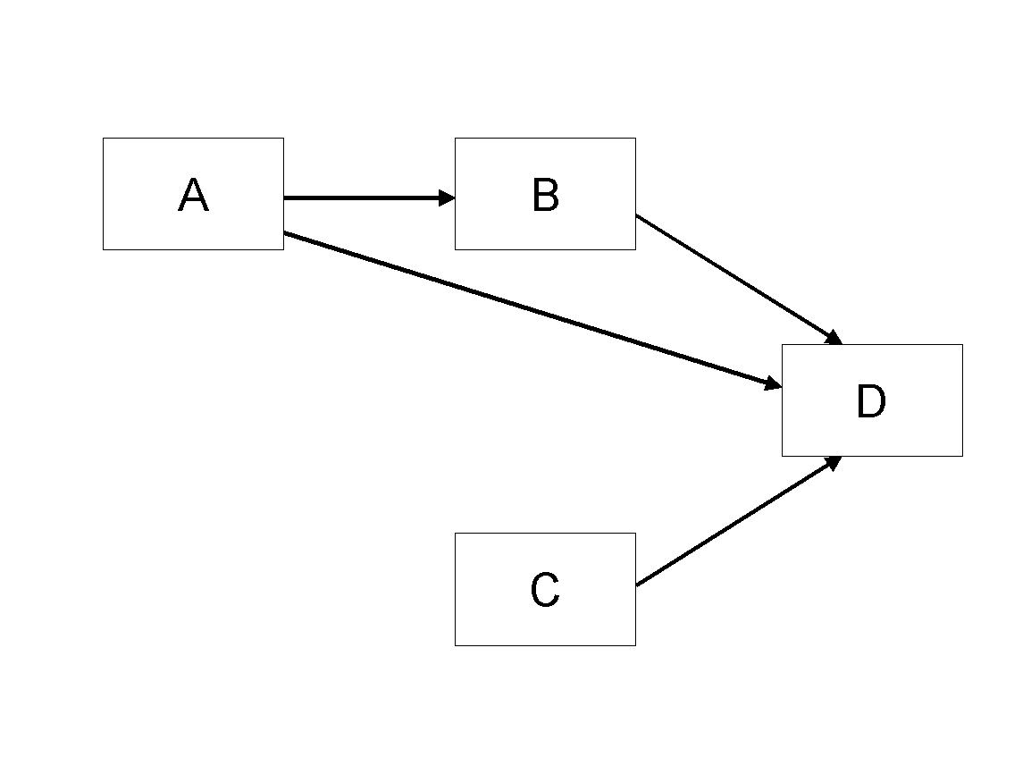
Figure 1. Modified Research Model

Table Style
Inserting a table in the text can work well. You may want to adjust the vertical spacing of the text in the tables. (In Word, use Format | Paragraph… and then the Line and Page Breaks tab. Generally, text in each field of a table will look better if it has equal amounts of spacing above and below it, as in Table 1.)
 | Treatment 1 | Treatment 2
Setting A | 125 | 95
Setting B | 85 | 102
Setting C | 98 | 85
Table 1. A Very Nice Table

Other Visual Media (e.g., video clips)
Submissions that rely on the use of visual media such as video, animation, visual analytics, etc., should embed links to these in their submission pdf. The visual media portion of the submission should be no more than 5 minutes (in total). Given the limitations of the review system, the visual media portion of the paper must be hosted outside the review system. We ask each author to create his/her own account with an open access provider of choice (e.g., linked video could be hosted in Vimeo or YouTube). Please use a pseudo user name in order to maintain anonymity during the review process. The visual media portion of the submission must be playable in a generic Internet browser. Please fine-tune for Firefox. Please verify that all links to visual media work as expected in the system-generated PDF prior to submitting the paper to the review system. Do not change your online media after submitting the paper for review. We recommend using Creative Commons Licenses for the visual media portion of the submission. If you have any other questions, please contact the program co-chairs.

Language, Style, and Content
With regard to spelling and punctuation, you may use any dialect of English (e.g., British, Canadian, US, etc.) provided this is done consistently. Hyphenation is optional. To ensure suitability for an international audience, please pay attention to the following:
- Write in a straightforward style.
- Try to avoid long or complex sentence structures.
- Briefly define or explain all technical terms that may be unfamiliar to readers.
- Explain all acronyms the first time they are used in your text – e.g., “primary care provider (PCP)”.
- Explain local references (e.g., not everyone knows all city names in a particular country).
- Be careful with the use of gender-specific pronouns (he, she) and other gendered words (chairman, manpower, man-months). Use inclusive language that is gender-neutral (e.g., they, s/he, chair, staff, staff-hours, person-years).

Conclusion
It is important that your submission to this call is especially written for a general audience. We very much look forward to receiving your proof-of-concept for an artefact that might be selected for inclusion at the ICIS 2026 IS arts- and culture-based artefact exhibition.

Acknowledgements (optional)
Please do not add acknowledgements to your original submission because it will help identify authors. Acknowledgements may be added later, if the proof-of-concept is accepted.
Use of generative artificial intelligence (AI): If you have used generative AI, you must clearly describe how it was used in the preparation of the artefact. Please see the ICIS Submission FAQ for further details of the AI policy.

References and Citations
References should be listed alphabetically by author name at the end of the paper in conformance with APA 7th edition. In-text citations should be indicated by the author’s last name and year of publication, e.g., (DeGross, 1977) or DeGross (1977). References must be complete, i.e., include, as appropriate, volume, number, month, publisher, city and state, editors, last name & initials of all authors, page numbers, etc. If you use EndNote, be aware that different versions of the software change the styles, creating some inconsistencies.
Your references should comprise only published (or preprint) materials accessible to the public. Proprietary information may not be cited.
References should be ordered in alphabetic order.

References

<<<Please ensure that all references are present, complete, and accurate as per the examples below, including DOIs>>>
Ackoff, R. L. (1967). Management misinformation systems. Management Science, 14(4), 147-156. https://doi.org/10.1287/mnsc.14.4.B147
Benbasat, I., & Zmud, R. W. (2003). The identity crisis within the IS discipline: Defining and communicating the discipline's core properties. MIS Quarterly, 27(2), 183-194. https://doi.org/10.2307/30036527
Bonini, C. P. (1963). Simulation of information and decision systems in the firm. Prentice-Hall.
Broadbent, M., Weill, P., O’Brien, T., & Neo, B. S. (1996). Firm context and patterns of IT infrastructure capability. Proceedings of the 14th International Conference on Information Systems, 13, 174-194. https://aisel.aisnet.org/icis1996/13
Carroll, J. (2005). The Blacksburgh Electronic Village: A study in community computing. In P. van den Besselaar & S. Kiozumi (Eds.), Digital Cities III: Information Technologies for Social Capital (pp. 43-65). Springer-Verlag. https://doi.org/10.1007/11407546_3

